**ORIENT INVERTER CEILING FANS:**

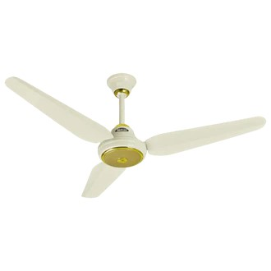

**Price: 14,895.00**

Orient Inverter Ceiling Fans are a masterpiece of innovative design and energy-efficient technology. Equipped with advanced inverter motors, these fans optimize airflow while minimizing power consumption, resulting in significant energy savings. With features such as whisper-quiet operation, variable speed control, and reversible functionality, Orient Inverter Ceiling Fans provide unparalleled comfort and flexibility. Their sleek and modern designs, robust construction, and rust-resistant coating ensure a long-lasting and visually stunning addition to any room. Ideal for residential and commercial spaces, Orient Inverter Ceiling Fans offer a perfect blend of style, substance, and sustainability, making them a superior choice for those seeking a reliable and eco-friendly cooling solution.

**Key features of orient inverter ceiling fans include:**

* **Inverter Motor:** Ensures energy efficiency and quieter operation.
* **Multiple Speed Settings:** Offers customizable airflow for comfort.
* **Durable Build:** High-quality materials for long-lasting performance.
* **Remote Control:** Convenient speed and setting adjustments from a distance.
* **Reversible Motor:** Allows for year-round use with both cooling and warming airflow.
* **Energy Efficient:** Consumes less power, reducing electricity costs.
* **Sleek Design:** Modern aesthetic to suit various room decors.